**Introduction:** How the brain processes information is an ongoing question in neuroscience, and a current approach that is garnering attention is the study of the connectome of the brain. Bold fMRI and EEG studies both use simple fourier domain analyses and information theoretic measures to determine the network connectivity between brain regions. However, critical assessment of whether these measures can robustly capture connectivity features in a large-scale dynamical network has not been properly explored. The focus of this study is to build networks with known dynamics, apply contemporary human subject electrophysiology approaches to it, and quantify the ability of those approaches in estimating the true connectivity of our network.

**Materials and Methods:** A coupled oscillator model was implemented to simulate simple brain network dynamics. A monte carlo simulation of the model was implemented to generate brain network and electrophysiological states over a given time period. Oscillatory features were then extracted through Fast Fourier Transform (FFT) based measures. Several connectivity and causal measures were implemented, including spectral coherence and correlation, complex phase synchrony, mutual information, granger causality, transfer entropy, linear and nonlinear coefficients of determination, partial directed coherence, and directed transfer function, among others. Using these measures, predicted network connectivity structures were generated and were compared to ground-truth connectivity of the model using several graph similarity measures, including the jaccard and cosine similarity metrics. Robustness against different noise sources, such as white noise and current leakage, was also explored.

**Results and Discussion:** Similarity results were calculated, as shown in Figure 1. The measure that performed the worst was complex phase synchrony, which is most likely due to large in-phase behaviors of a coupled oscillator. The other measures ranged from .57 to .84, with 8 measures within the range of .78 - .84. Compared to the Erdos-Reyni graph, with binomial distribution of similarity centered around .5, the p-value for the similarity results for each measure was <.001. Partial methods were also explored, with the residuals between node data-sets calculated first, and then the measures applied to the resulting residuals. The benefit of using partial measures over the regular

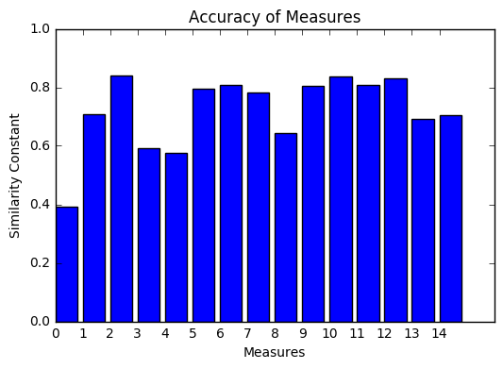

**Figure 1.** The distance similarity constant shows how close the predicted network is to the ground-truth network, with 0 representing no similarity and 1 representing full similarity. The measures include from left to right: phase synchrony, correlation, partial correlation, coherence, partial coherence, mutual information, partial mutual information, transfer entropy, partial transfer entropy, pearson correlation, partial pearson correlation, nonlinear correlation, partial nonlinear correlation, partial directed coherence, and directed transfer function,

**Conclusion:** rttr

[0.39060795177452518, 0.70839230669609077, 0.84170523645749895, 0.59259727596862666, 0.57476955518260697, 0.79497032905937981, 0.8067688811343201, 0.78297107049603609, 0.64372186377172447, 0.80548581732025937, 0.83732226634415186, 0.80733865360808343, 0.83088491243769746, 0.69148848835255083, 0.70627749530762507]